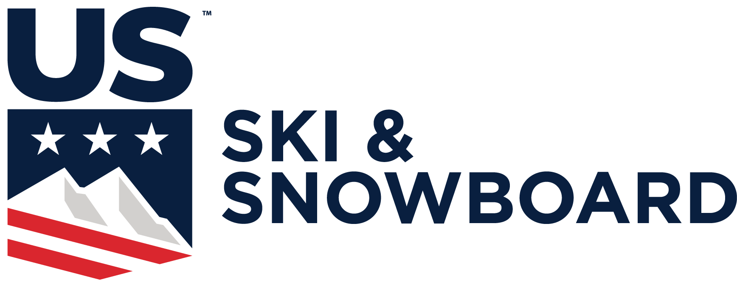

NORDIC HEAD TAX FORM

Title of Competition:

NRL Race Code:

Date of Competition:

Location of Competition:

Person Completing This Form:

Address:

City:
ST
Zip

Sanctioned race:
$3 x (number of competitors) = $

Head tax ($300 per day maximum)

COMPLETE RESULTS MUST ACCOMPANY THIS FORM

Number of Competitors per Competition Day:

Total Amount Sent:

Check #

Date:

Please make checks payable to: U.S. Ski & Snowboard. Remit to:

U.S. Ski & Snowboard/Nordic
P.O. Box 100
Park City, UT 84060

