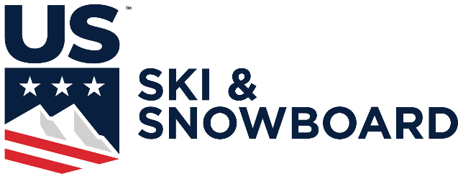

NORDIC HEAD TAX FORM

Title of Competition:

Race Code (s):

Date of Competition:

Location of Competition:

Person Completing This Form:

Sanctioned race:
$5 x (number of competitors) = $
Head tax $600 per day maximum

COMPLETE RESULTS MUST ACCOMPANY THIS FORM

Number of Competitors per Competition Day:

Total Amount Sent:

Check #

Date:

Please make checks payable to U.S. Ski & Snowboard
Return this form along with payment and the results packet to:
Competition Services | U.S. Ski & Snowboard | PO Box 100 | Park City UT 84060

